Built2gsd  
VoiceMail Helper Software Application

10/17/2018

# Overview

## Project Background and Description

Having switched phones from T-Mobile to Verizon Wireless, I found the layout from Verizon to be slow, tedious, and unnecessarily complicated. They have a PDF user guide that was helpful. What about creating an app that helps you with your voicemail based on the user guide?

## Project Scope

Turn the PDF into a mobile app. Due to the nature of this being Verizon’s the best use is for Free and Practical application of project creation.

https://scache.vzw.com/dam/support/pdf/VM_2.pdf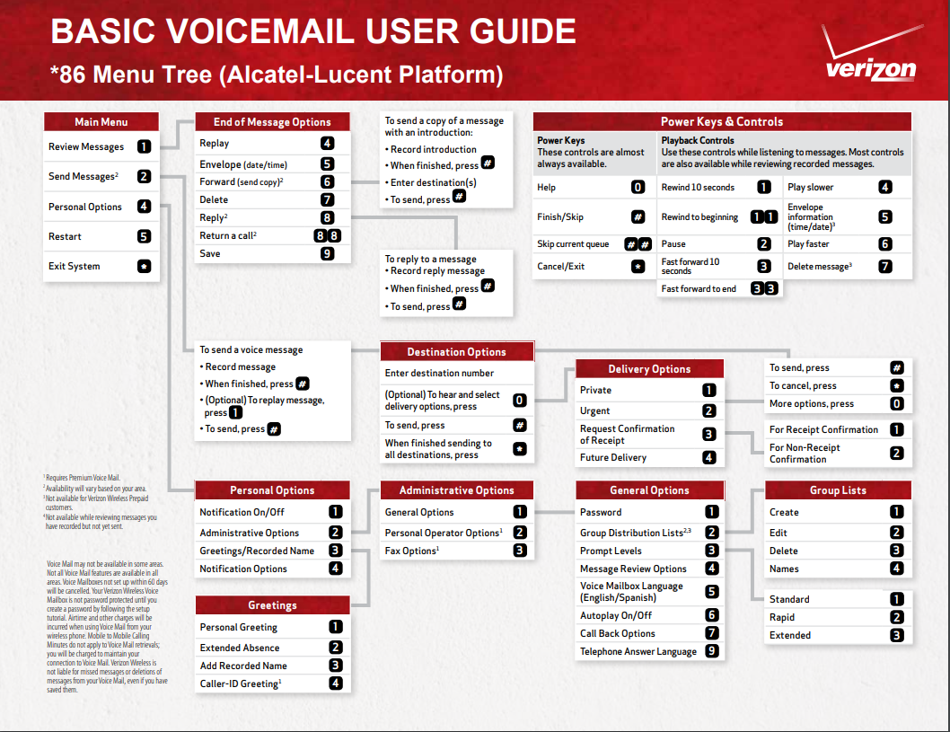

## High-Level Requirements

|  |  |
| --- | --- |
|  | Describe the high level requirements for the project. For example: |

The new system must include the following:

* Ability to allow both internal and external users to access the application without downloading any software
* Ability to interface with the existing data warehouse application
* Ability to incorporate automated routing and notifications based on business rules

## Deliverables

|  |  |
| --- | --- |
|  | List agencies, stakeholders or divisions which will be impacted by this project and describe how they will be affected by the project. |

## Affected Parties

|  |  |
| --- | --- |
|  | List business processes or systems which will be impacted by this project and describe how they will be affected. |

## Affected Business Processes or Systems

|  |  |
| --- | --- |
|  | Describe any specific components that are excluded from this project. |

## Specific Exclusions from Scope

|  |  |
| --- | --- |
|  | Describe how you plan to implement the project. For example, will all parts of the project be rolled out at once or will it be incremental? What will be included in each release? |

## Implementation Plan

|  |  |
| --- | --- |
|  | Include recommendations that lead to your proposed solution. Summarize what you’re proposing to do and how you’re going to meet the goals. You’ll be able to expand on the details within the ‘Our Proposal’ section. |

## High-Level Timeline/Schedule

|  |  |
| --- | --- |
|  | Describe what the high level timeline/schedule will be to plan, design, develop and deploy the project. Generally, by when do you expect this project to be finished? |

# Approval and Authority to Proceed

We approve the project as described above, and authorize the team to proceed.

|  |  |  |
| --- | --- | --- |
| Name | Title | Date |
|  |  |  |
|  |  |  |
|  |  |  |

|  |  |  |  |  |  |  |  |  |
| --- | --- | --- | --- | --- | --- | --- | --- | --- |
|  |  |  |  |  |  |  |  |  |
| Approved By |  |  | Date |  | Approved By |  |  | Date |